Echo

1. Input a line of text and display it on standard output
2. Declare a variable and echo its value. For example, Declare a variable of
x and assign its value=10.
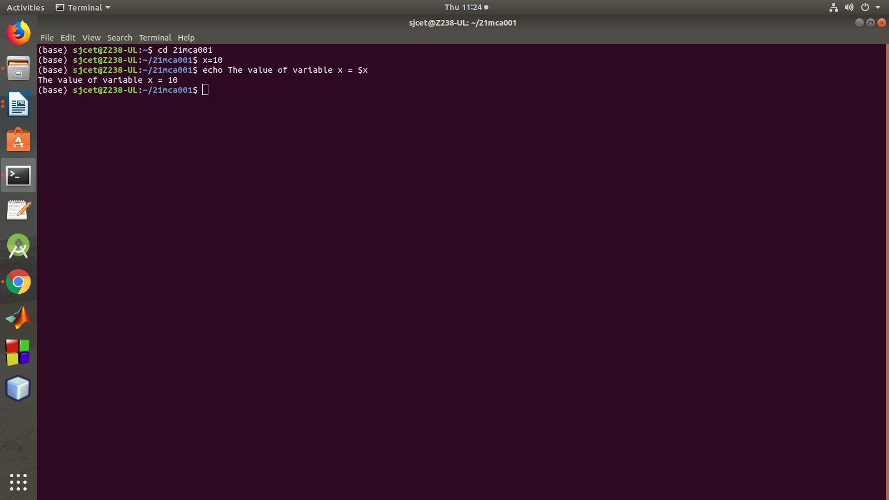

3. Using option ‘\b‘ – backspace with backslash interpretor ‘-e‘ which
removes all the spaces in between.
4. Using option ‘\n‘ – New line with backspace interpretor ‘-e‘ treats new
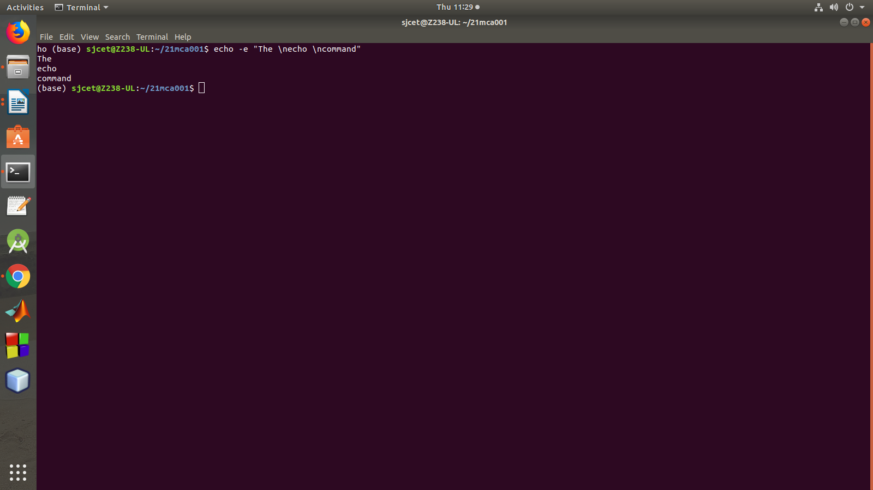
line from where it is used.

5. Using option ‘\t‘ – horizontal tab with backspace interpretor ‘-e‘ to
have horizontal tab spaces.
6.Using option ‘\v‘ – vertical tab with backspace interpretor ‘-e‘ to have
vertical tab spaces.
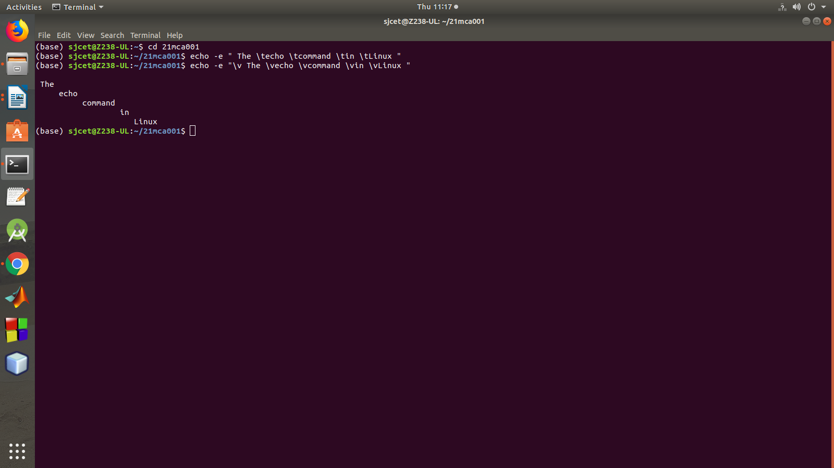

Read

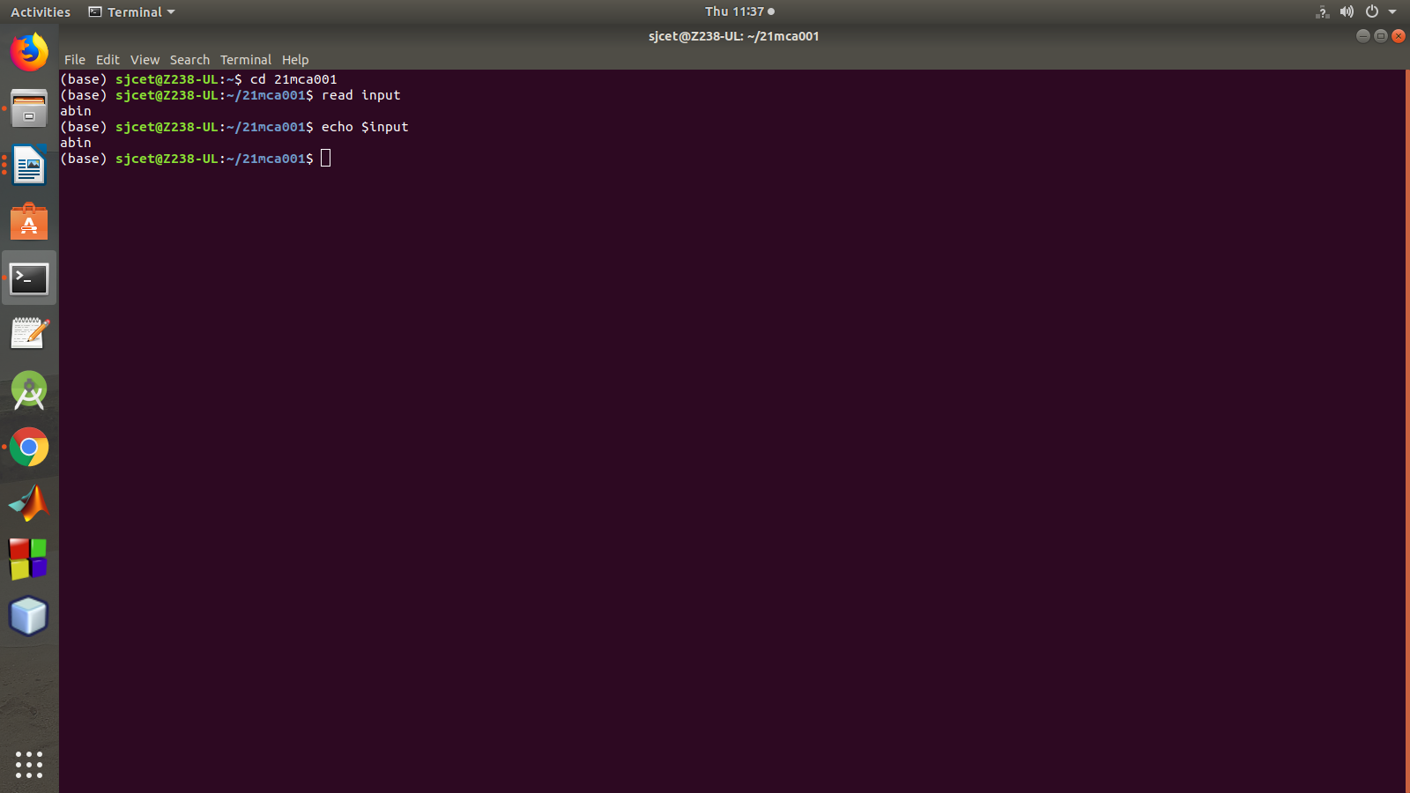

arguement and piping

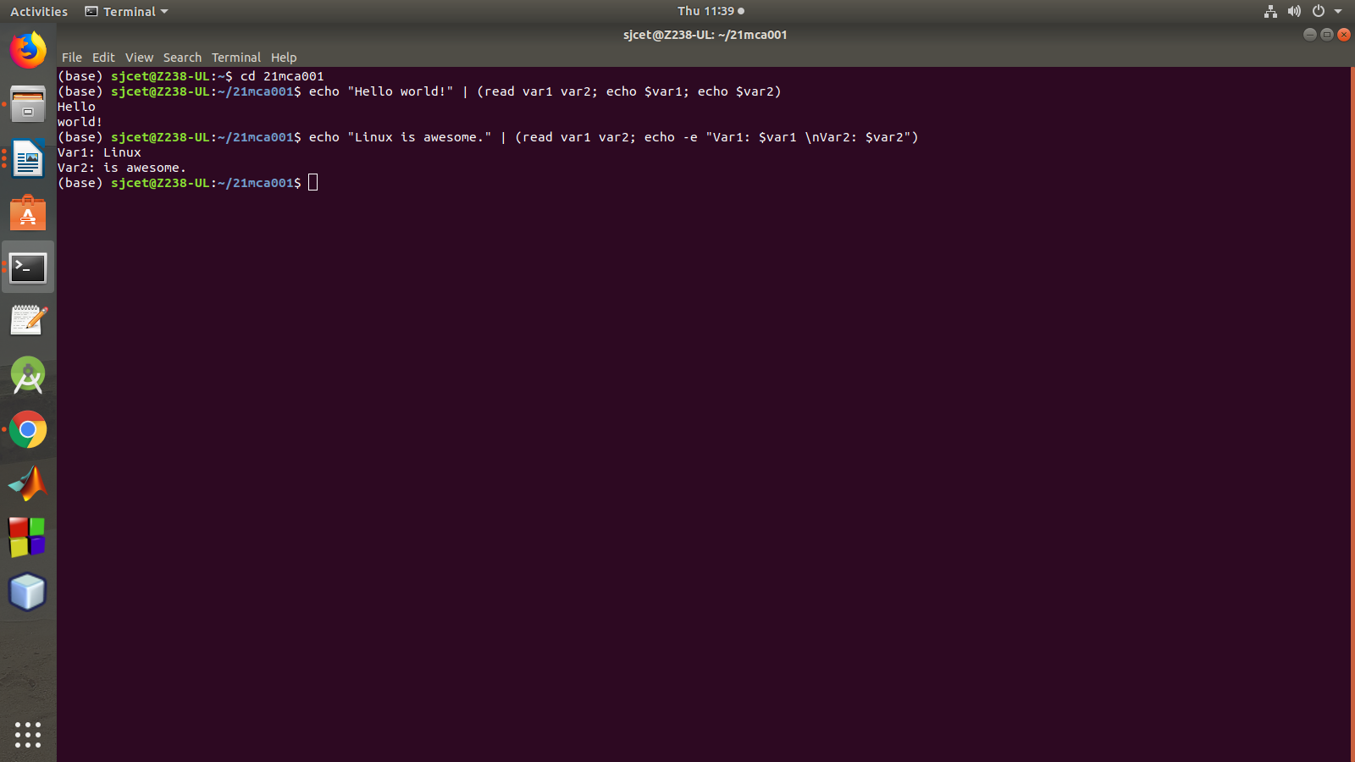

Changing the Delimiter
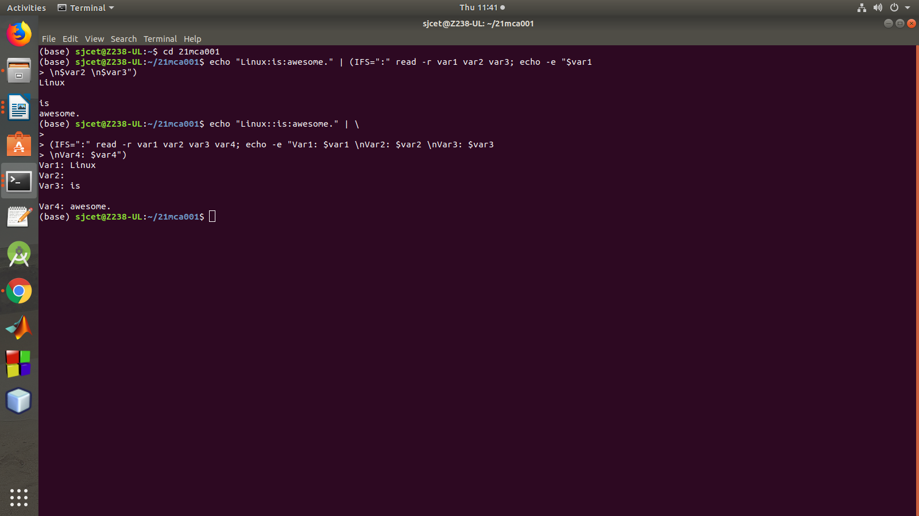

Prompt String
